All Weapon

**Stage1**

**Pocket Knife**

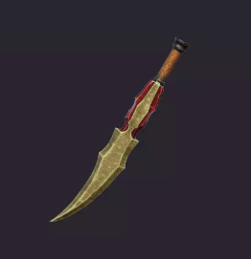

Link：[FREE - Stylized Weapons | 3D 武器 | Unity Asset Store](https://assetstore.unity.com/packages/3d/props/weapons/free-stylized-weapons-216047)

Operation: **Left Click** Melee Attack

Damage: Melee (15)

**Dagger**

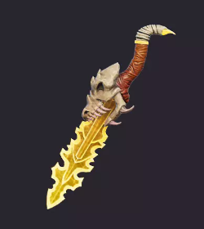

Link：[FREE - Stylized Weapons | 3D 武器 | Unity Asset Store](https://assetstore.unity.com/packages/3d/props/weapons/free-stylized-weapons-216047)

Operation: **Left Click** Melee Attack, **Right Click** Throw Attack (amount -1)

Damage: Melee (25), Throw (10)

**Iron Sword**

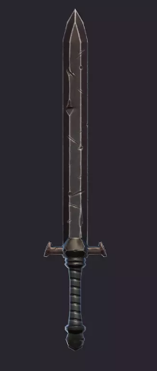

Link: [FREE - Stylized Weapons | 3D 武器 | Unity Asset Store](https://assetstore.unity.com/packages/3d/props/weapons/free-stylized-weapons-216047)

Operation: **Left Click** Light Attack, **Right Click** Heavy Attack

Damage: Light (50), Heavy (100)

**Stone Axe**

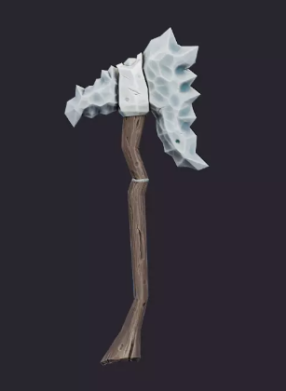

Link: [FREE - Stylized Weapons | 3D 武器 | Unity Asset Store](https://assetstore.unity.com/packages/3d/props/weapons/free-stylized-weapons-216047#content)

Operation: **Left Click** Light Attack, **Right Click** Heavy Attack  
Damage:

**Wooden Shield**

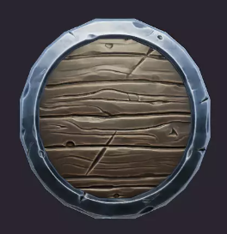

Link: [FREE - Stylized Weapons | 3D 武器 | Unity Asset Store](https://assetstore.unity.com/packages/3d/props/weapons/free-stylized-weapons-216047)

Operation: **Left Click** Defense

Durability: 50

**Stage2**

**Iron Shield**

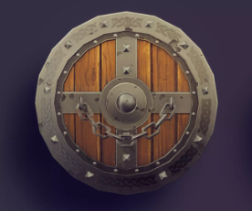

Link: [FREE - RPG Weapons | 3D 武器 | Unity Asset Store](https://assetstore.unity.com/packages/3d/props/weapons/free-rpg-weapons-199738)

Operation: **Left Click** Defense

Durability: 100

**Elven Bow**

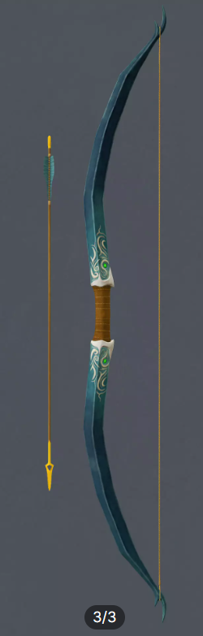

Link: [Elven Long Bow | 3D 武器 | Unity Asset Store](https://assetstore.unity.com/packages/3d/props/weapons/elven-long-bow-17728#content)

Operation: **Left Click** one shot

Damage:

Skill: **Right Click** increase move speed (duration 10s) (cooldown 20s)

Limitation: if arrow amount is 0, unable to attack, first time get will have 20 arrows, rest need buy in shop

**Grim Reaper's Scythe**

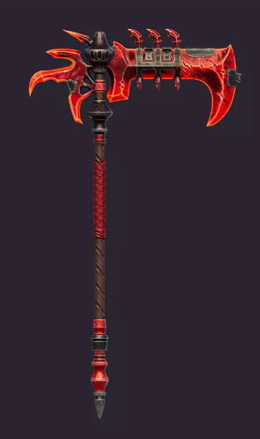

Link: [FREE - Stylized Weapons | 3D 武器 | Unity Asset Store](https://assetstore.unity.com/packages/3d/props/weapons/free-stylized-weapons-216047)

Operation: **Left Click** Light Attack, **Right Click** Heavy Attack

Damage: Light (), Heavy ()

Skill: successfully kill enemy will increase player’s max hp by 1

**Hammer**

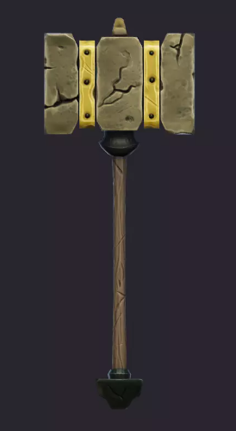

Link: [FREE - Stylized Weapons | 3D 武器 | Unity Asset Store](https://assetstore.unity.com/packages/3d/props/weapons/free-stylized-weapons-216047#content)  
Operation: **Left Click** Light Attack(should be slow), **Right Click** Heavy Attack(Hammer on the ground)

Damage: Light(), Rotation()

**Guan Dao**

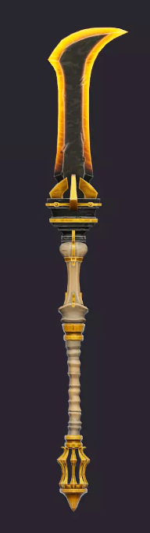

Link: [FREE - Stylized Weapons | 3D 武器 | Unity Asset Store](https://assetstore.unity.com/packages/3d/props/weapons/free-stylized-weapons-216047)  
Operation: **Left Click** Light Attack, **Hold** **Right Click** keep Rotate weapon

Damage: Light(), Rotation()

**Stage3**

**Golden Shield**

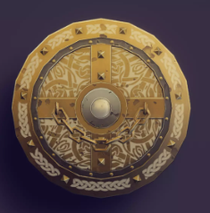

Link: [FREE - RPG Weapons | 3D 武器 | Unity Asset Store](https://assetstore.unity.com/packages/3d/props/weapons/free-rpg-weapons-199738)

Operation: **Left Click** Defense (if successfully defense, repel enemy 5m away)

Durability: 200

**Runes Axe**

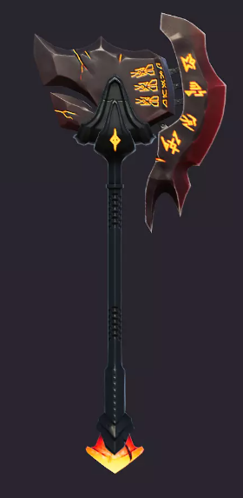

Link: [FREE - Stylized Weapons | 3D 武器 | Unity Asset Store](https://assetstore.unity.com/packages/3d/props/weapons/free-stylized-weapons-216047#content)

Operation: **Left Click** Light Attack  
Skill: **Right Click** Slash Wave (15s cooldown)  
Damage: Light Attack(), Slash Wave()

**Lightning Sword**

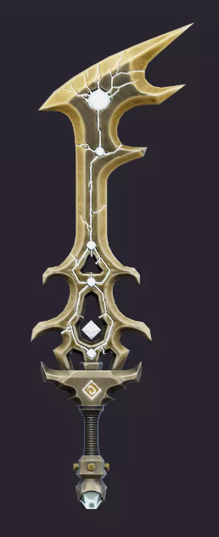

Link: [FREE - Stylized Weapons | 3D 武器 | Unity Asset Store](https://assetstore.unity.com/packages/3d/props/weapons/free-stylized-weapons-216047#content)

Operation: **Left Click** Light Attack  
Skill: **Right Click** Lightning Circle (15s cooldown)

Damage: Light Attack(), Lightning Circle()

**Shuriken**

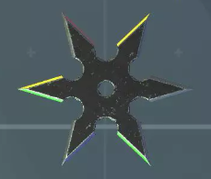

Link: [Shuriken pack | 3D | Unity Asset Store](https://assetstore.unity.com/packages/3d/shuriken-pack-89418)

Operation: **Left Click** one shot (amount -1), **Right Click** Triple Shot (amount -3)

Damage:

Limitation: if shuriken amount is 0, unable to attack, first time gain have 30 amount, can stack.

**Musket**

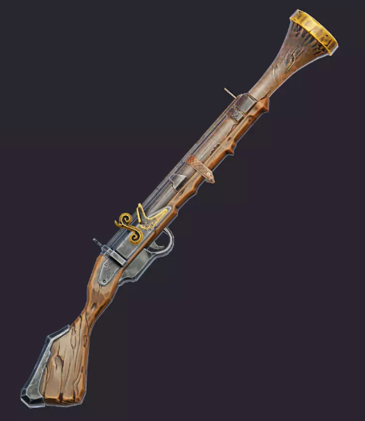

Link: [FREE - Stylized Weapons | 3D 武器 | Unity Asset Store](https://assetstore.unity.com/packages/3d/props/weapons/free-stylized-weapons-216047#content)  
Operation:

Damage: